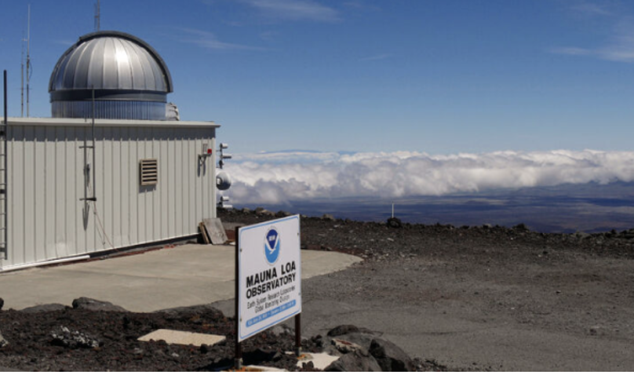
Since 1958, scientists have been measuring the concentration of carbon dioxide (CO₂) gas in the atmosphere. They record the data at Mauna Loa, a mountain on the island of Hawai’i in the Northern Hemisphere.

The data in the table shows Carbon Dioxide concentration in the atmosphere over a 12-month period from 2020-2021.

Month | Carbon Dioxide concentration  (in parts per million)
November 2020 | 413.1
December 2020 | 414.2
January 2021 | 415.5
February 2021 | 416.7
March 2021 | 417.6
April 2021 | 419.0
May 2021 | 419.1
June 2021 | 418.9
July 2021 | 416.9
August 2021 | 414.4
September 2021 | 413.3
October 2021 | 413.9

Write down the month when scientists recorded:

- The lowest concentration of Carbon dioxide _____________________
- The highest concentration of Carbon dioxide _____________________

Calculate the mean concentration of Carbon Dioxide over the 12-month period: __________

Use the axes below to plot a graph of the concentration of carbon dioxide concentration during the 12-month period.

Draw a line to connect the data points.
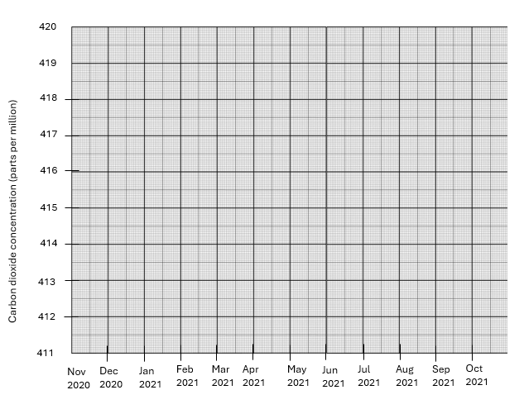
Northern Hemisphere winter lasts from December to February. Describe how the concentration of carbon dioxide changes during and immediately after winter.
______________________________________________________________________________________________________________________________________________________________________________

Northern Hemisphere summer lasts from June to August. Describe how the concentration of carbon dioxide changes during and immediately after summer.

______________________________________________________________________________________________________________________________________________________________________________

Using your knowledge of photosynthesis, explain the changes in concentration of carbon dioxide during winter and in summer.
__________________________________________________________________________________________________________________________________________________________________________________________________________________________________________________________________________________________________________________________________________________________________________________________________________________________________________________________________________________________________________________________________________

This graph shows how the concentration of carbon dioxide from Mauna Loa has changed between 1958 and 2022.

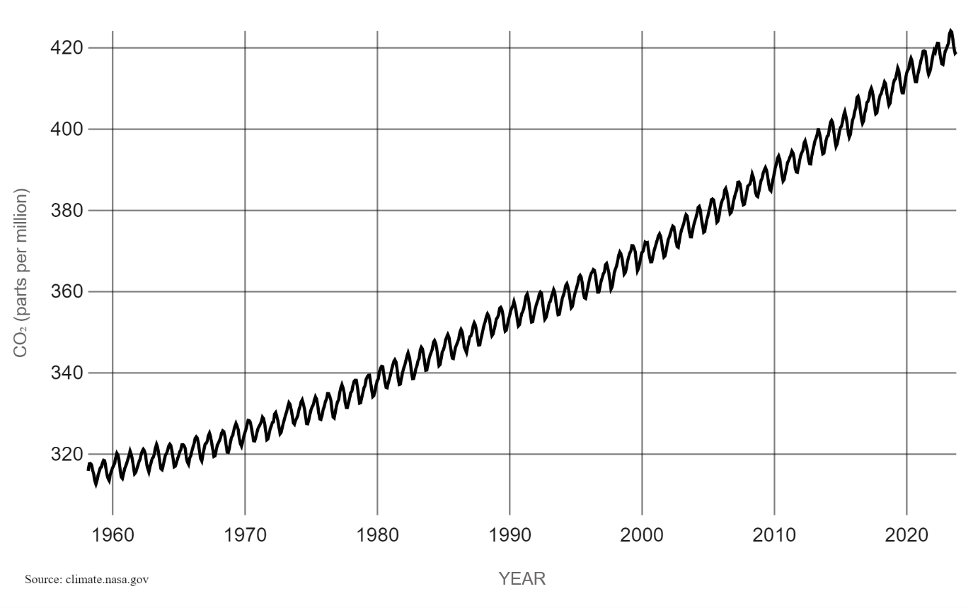
Apart from the seasonal cycle you have already looked at, describe and explain how the concentration of carbon dioxide in the atmosphere has changed over the period:
______________________________________________________________________________________________________________________________________________________
______________________________________________________________________________________________________________________________________________________
______________________________________________________________________________________________________________________________________________________

The graph below shows how the concentration of carbon dioxide varies during the year at two different places on the Earth.
- the dashed blue line is Mauna Loa in the Northern Hemisphere
- the solid purple line is the South Pole in the Southern Hemisphere

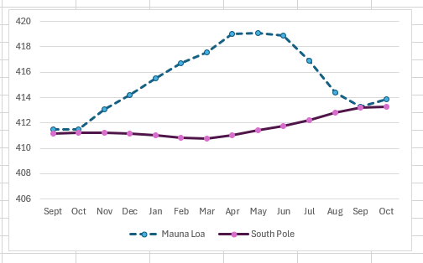

Look at the graph. Describe two differences between carbon dioxide changes at the South Pole and at Mauna Loa in the Northern Hemisphere.

Difference 1 __________________________________________________________________________
__________________________________________________________________________

Difference 2 __________________________________________________________________________
_____________________________________________________________________________________

Give an explanation for these differences:

___________________________________________________________________________
__________________________________________________________________________
___________________________________________________________________________
___________________________________________________________________________
___________________________________________________________________________
___________________________________________________________________________
___________________________________________________________________________
__________________________________________________________________________

